
Manual Install Guide
ASR Mobility Agent

2/9/2021

Cognizant Microsoft Business Group
20 North Wacker Drive #530
Chicago, IL 60606

Notice of Confidentiality ©2021 Cognizant Microsoft Business Group All rights reserved.

IS SUBJECT TO THE TERMS OF THE COGNIZANT MICROSOFT BUSINESS GROUP NON-DISCLOSURE AGREEMENT. NEITHER THIS DOCUMENT NOR ITS CONTENTS MAY BE REVEALED OR DISCLOSED TO UNAUTHORIZED PERSONS OR SENT OUTSIDE THE AFOREMENTIONED COMPANY WITHOUT PRIOR PERMISSION FROM COGNIZANT MICROSOFT BUSINESS GROUP
Table of Contents
Prerequisities 3
Windows Installation 4
GUI Install 4
Command Line Install 5
Linux Installation 6

Prerequisities
Generate Passphrase on Each Configuration Server and Locate Installer Files
- Sign in to your configuration server, and then open a command prompt window as an administrator.
- To change the directory to the bin folder, execute the following command:
  - cd %ProgramData%\ASR\home\svsystems\bin
- To generate the passphrase file, execute:
  - genpassphrase.exe -v > MobSvc.passphrase
- Your passphrase will be stored in the file located at
  - %ProgramData%\ASR\home\svsystems\bin\MobSvc.passphrase
- Locate the correct installer. Go to %ProgramData%\ASR\home\svsystems\pushinstallsvc\repository folder on configuration server. Check which installer you’ll need based on the following table.

Installer file | Operating system (64-bit only)
Microsoft-ASR_UA*Windows*release.exe | Windows Server 2016; Windows Server 2012 R2; Windows Server 2012; Windows Server 2008 R2 SP1
Microsoft-ASR_UA*RHEL6-64*release.tar.gz | Red Hat Enterprise Linux (RHEL) 6.*
Microsoft-ASR_UA*RHEL6-64*release.tar.gz | CentOS 6.*
Microsoft-ASR_UA*RHEL7-64*release.tar.gz | Red Hat Enterprise Linux (RHEL) 7.*
Microsoft-ASR_UA*RHEL7-64*release.tar.gz | CentOS 7.*
Microsoft-ASR_UA*SLES12-64*release.tar.gz | SUSE Linux Enterprise Server 12 SP1,SP2,SP3
Microsoft-ASR_UA*SLES11-SP3-64*release.tar.gz | SUSE Linux Enterprise Server 11 SP3
Microsoft-ASR_UA*SLES11-SP4-64*release.tar.gz | SUSE Linux Enterprise Server 11 SP4
Microsoft-ASR_UA*OL6-64*release.tar.gz | Oracle Enterprise Linux 6.4, 6.5
Microsoft-ASR_UA*UBUNTU-14.04-64*release.tar.gz | Ubuntu Linux 14.04
Microsoft-ASR_UA*UBUNTU-16.04-64*release.tar.gz | Ubuntu Linux 16.04 LTS server
Microsoft-ASR_UA*DEBIAN7-64*release.tar.gz | Debian 7
Microsoft-ASR_UA*DEBIAN8-64*release.tar.gz | Debian 8

Windows Installation

GUI Install
- Copy the installer and the passphrase file to a local folder (for example, c:\Temp) on the server that you want to protect and run it.
- In Installation Option, select Install mobility service.
- Select the installation location > Install.
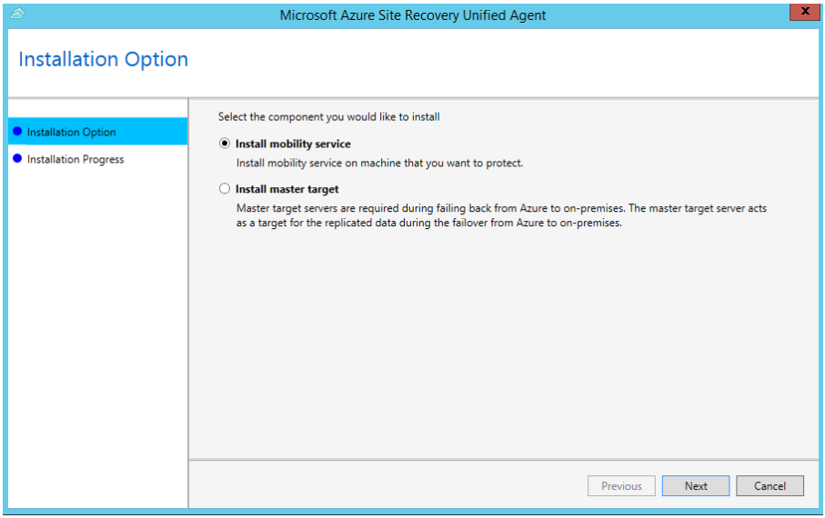
- Monitor the installation in Installation Progress. After the installation is finished, select Proceed to Configuration to register the service with the configuration server.
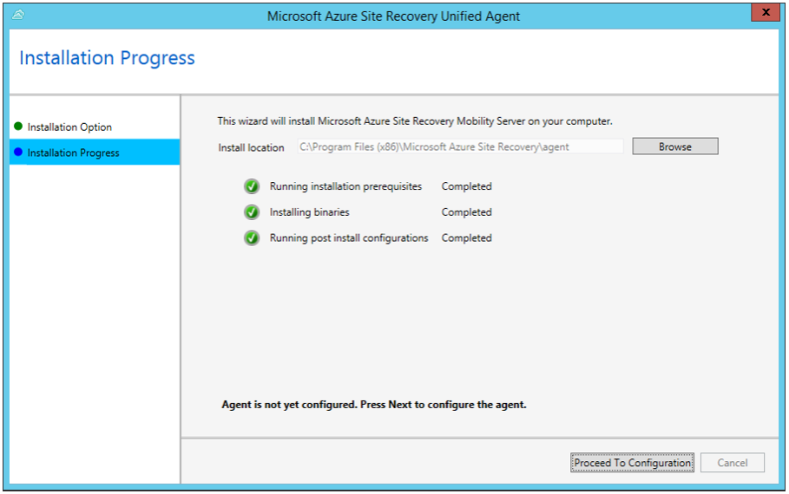

- In Configuration Server Details, specify the IP address and passphrase from the passphrase file you copied.
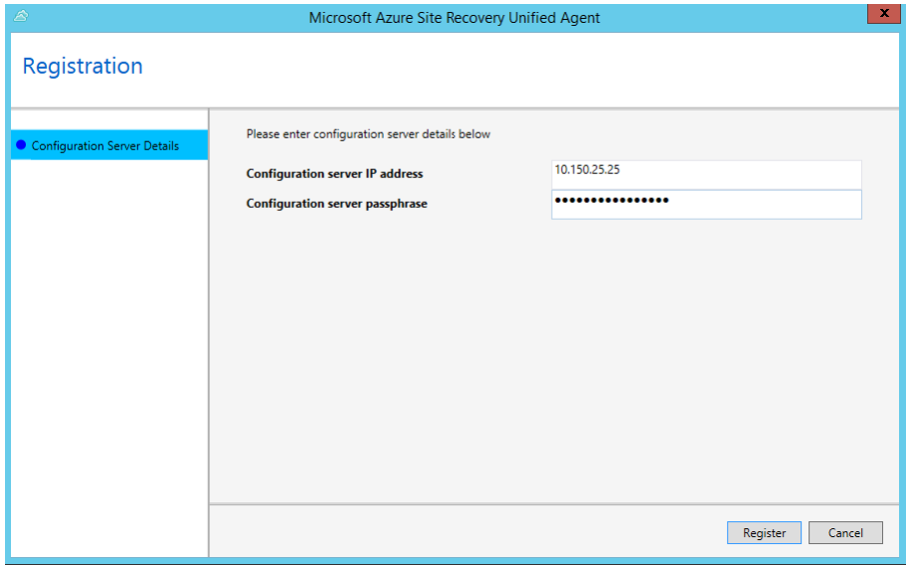
- Select Register to finish the registration.
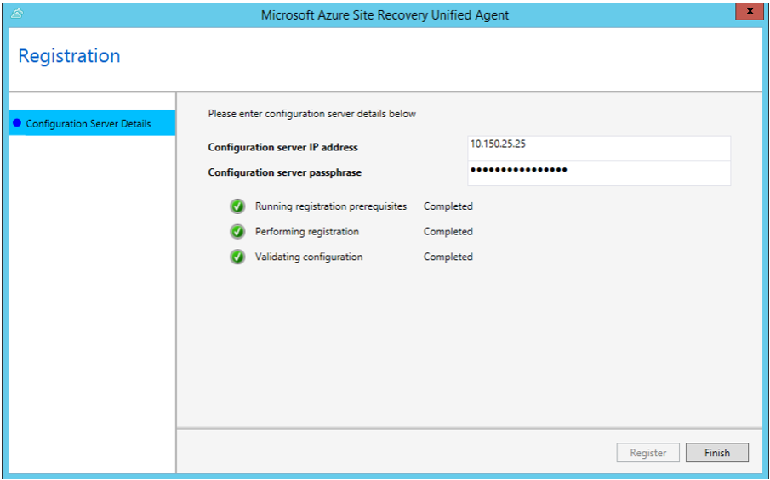

Command Line Install
- Copy the installer and the passphrase file to a local folder (for example, C:\Temp) on the server that you want to protect
- Open a command prompt as Administrator
- Extract the agent installer by running the following commands:
cd C:\Temp
ren Microsoft-ASR_UA*Windows*release.exe MobilityServiceInstaller.exe
MobilityServiceInstaller.exe /q /x:C:\Temp\Extracted
cd C:\Temp\Extracted
Run the following commands to install the Mobility Service:
UnifiedAgent.exe /Role "MS" /InstallLocation "C:\Program Files (x86)\Microsoft Azure Site Recovery" /Platform "VmWare" /Silent
- After installation is finished, the Mobility Service must be registered to the configuration server. Run the following commands to register the agent with the Configuration Server:
cd C:\Program Files (x86)\Microsoft Azure Site Recovery\agent
UnifiedAgentConfigurator.exe /CSEndPoint <IP of Configuration Server> /PassphraseFilePath <PassphraseFilePath>

Linux Installation

- Copy the installer and the passphrase file to a local folder (for example, /tmp) on the server that you want to protect. In a terminal, run the following commands to change to the directory with the installer tar file and extract it:

cd /tmp
tar -xvf <filename>

- Install with the following command:
sudo ./install -r MS -v VmWare

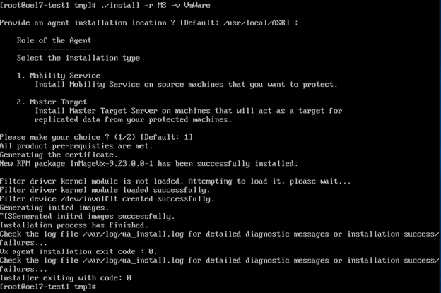

- After installation is finished, the Mobility Service must be registered to the configuration server. Run the following command to register Mobility Service with the configuration server:
/usr/local/ASR/Vx/bin/UnifiedAgentConfigurator.sh -i <IP of Configuration Server> -P /tmp/MobSvc.passphrase

